

*School of Mechanical & Manufacturing Engineering (SMME),*

*Department of Aerospace Engineering*

**Title: Project Report**

**Name: Anzish Fatima**

**Class: AE-01**

**Course**: FOP II

**Course Code**: CS-

**Date Of submission: 20th November 2024**

**Instructor: Ma’am Laiba Waheed**

**Project:**

**Flappy Bird Game**

**Screenshots of program:**

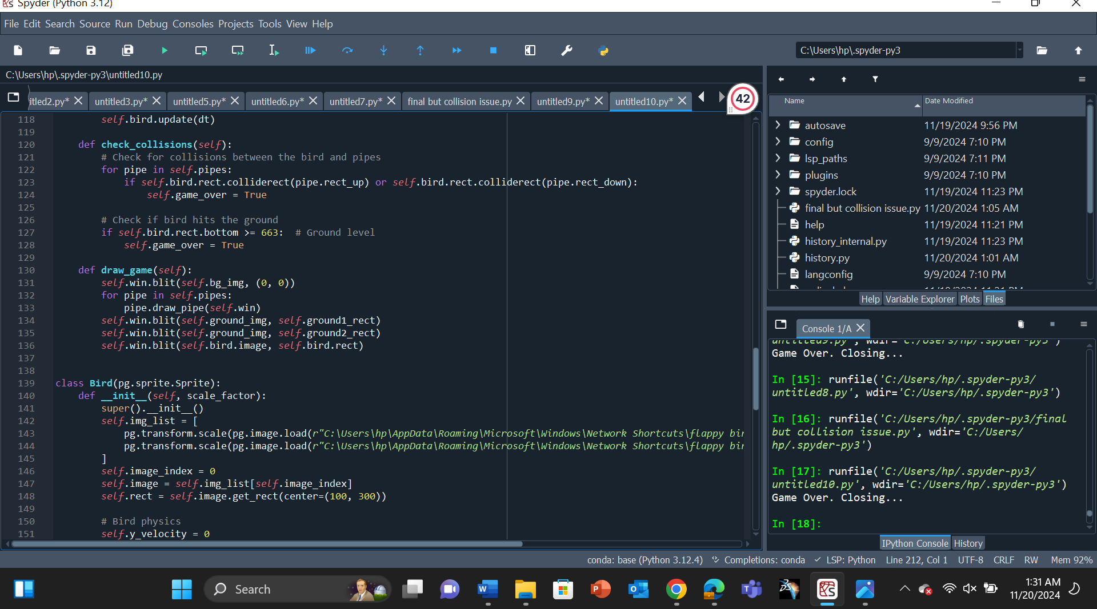

**Output:**

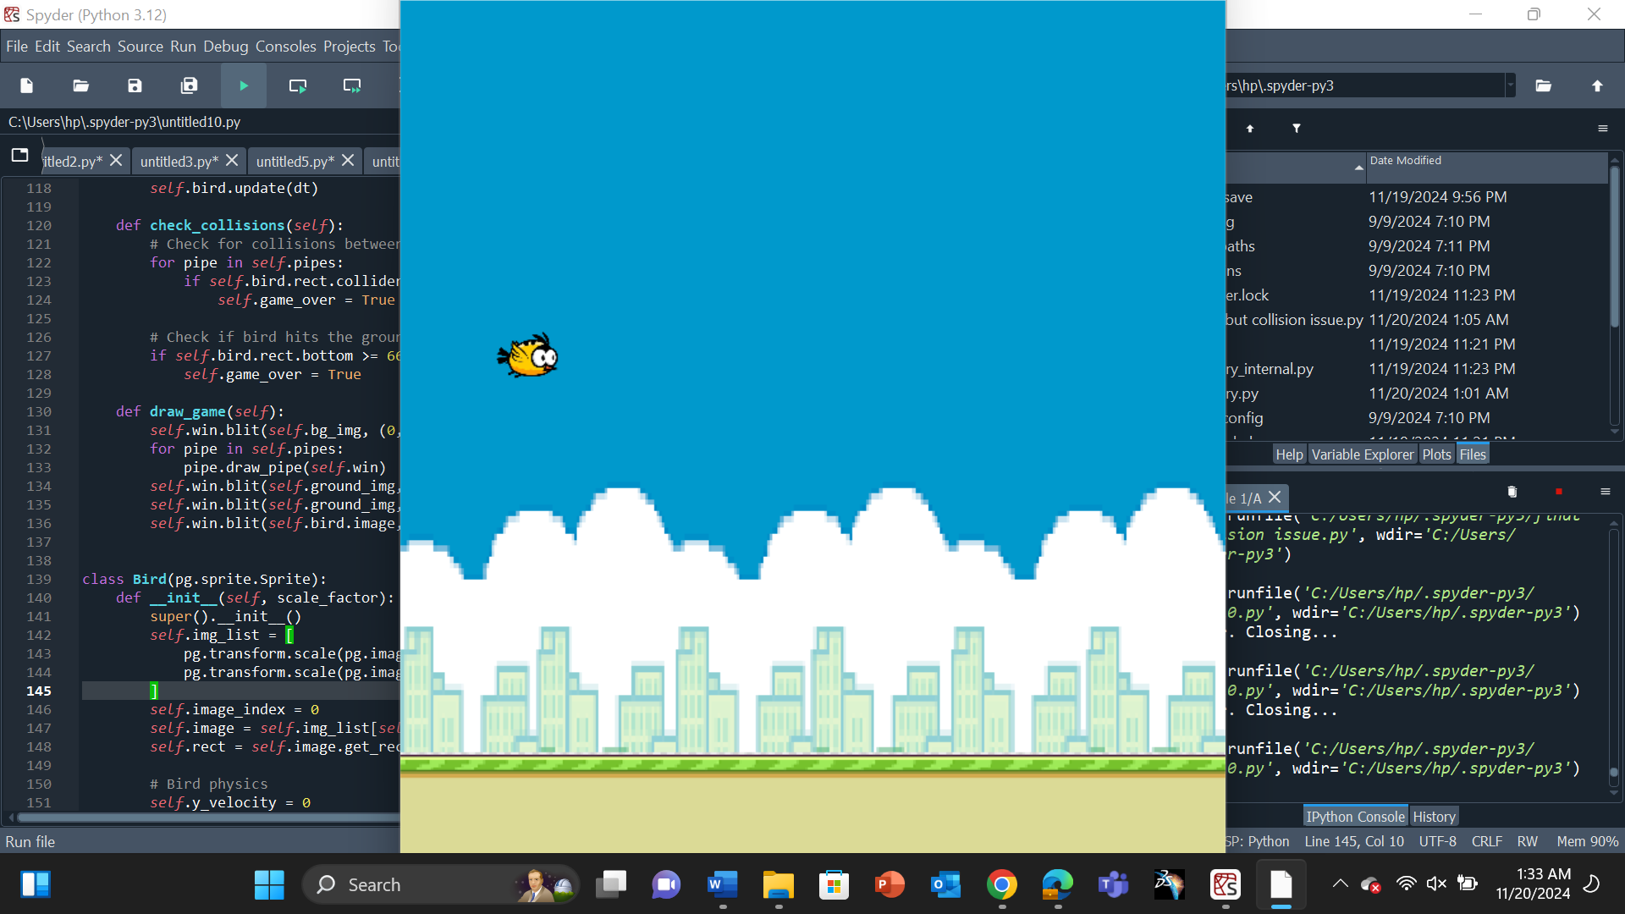

**Objectives**

* Learn Python application and enhancing the programming skills.

**Key Components:**

1. **Background and Ground Movement**:
   * The background is a static image that scrolls to give the illusion of movement.
   * The ground consists of two images that scroll seamlessly.
2. **Bird Physics**:
   * The bird is a sprite with gravity applied, which pulls it down.
   * Users press the spacebar to make the bird flap upward.
3. **Pipes**:
   * Pipes are dynamically generated obstacles that move toward the bird.
   * They consist of upper and lower parts, maintaining a fixed gap.
4. **Collision Detection**:
   * The game checks for collisions between the bird and pipes or the ground.
   * The game ends if a collision is detected.
5. **Game States**:
   * The game has two states: idle (waiting for the user to press Enter) and active (gameplay).

**Modules and Classes:**

* **Game**:
  + Initializes the game window and manages the game loop.
  + Handles events, updates sprites, and manages collision checks.
* **Bird**:
  + Represents the player-controlled bird.
  + Implements movement physics (gravity, flap, and boundary checks).
* **Pipe**:
  + Represents the obstacles.
  + Includes methods for drawing and updating the pipes' positions.

**Libraries Used:**

* Pygame
* Pathlib
* Sys
* Random
* Time

**Code Explanation**

**Game Class**

* Manages the game lifecycle.
* Implements the game loop that handles events, updates the game state, and renders the screen.
* Handles the ground scrolling logic.

**Bird Class**

* Represents the bird sprite.
* Implements gravity and flap mechanics.
* Animates the bird using sprite frames.

**Pipe Class**

* Dynamically generates upper and lower pipes with random heights.
* Moves pipes horizontally and removes off-screen pipes to save memory.

**Collision Handling**

* Checks for overlaps between the bird's bounding box and pipes or the ground.
* Ends the game if a collision is detected.

**Sources:**

YouTube

**Conclusion:**

This project provided the good knowledge about the python and game developing. It also enhanced the knowledge about the different python libraries. In the pygame the game is developed which provided the game the window and we imported other libraries such as os, time etc.